**Web Programming**

**(LAB Session-09)**

* **Working with JavaScript for Form Validations 1.**

**You need to apply different validations as per below requirement using java script.**

1. **Enrolment number field can’t be empty. It is a required field. Alert the user if it is blank at time of submission.**

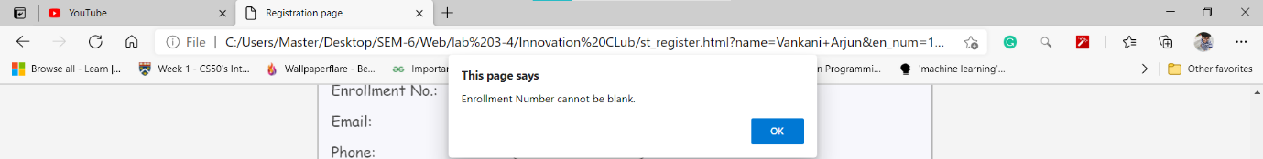

1. **User can’t enter anything except digits in enrolment number field and the length of the enrolment no. should be exactly 12 digits. If any of these two requirements not met, alert the user on form submission.**

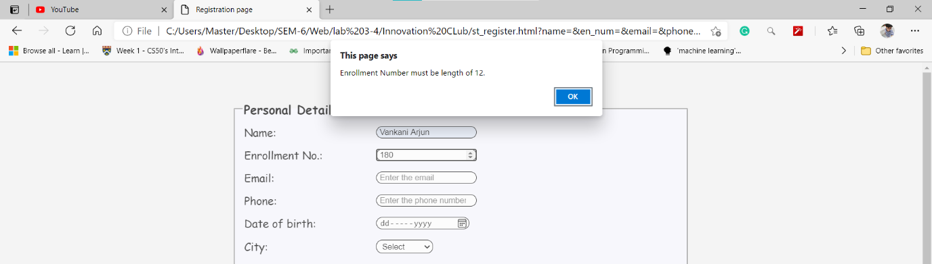

1. **Create a regular expression that can identify an email id and verify the email id entered by user is valid using the Reg Exp. If found not proper, alert the user.**

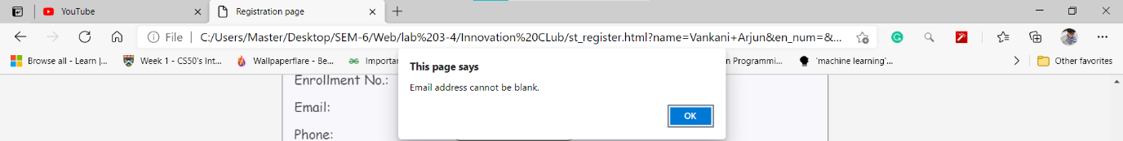

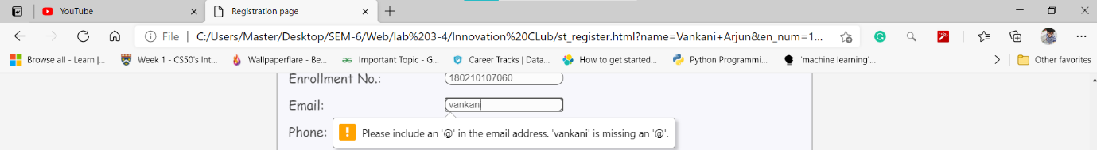

1. **Calculate user’s age based on the birthdate entered by user. If the age is less than 18 years or greater than 23 years then alert user that he/she is not allowed to register.**

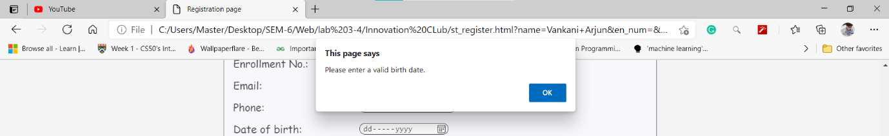

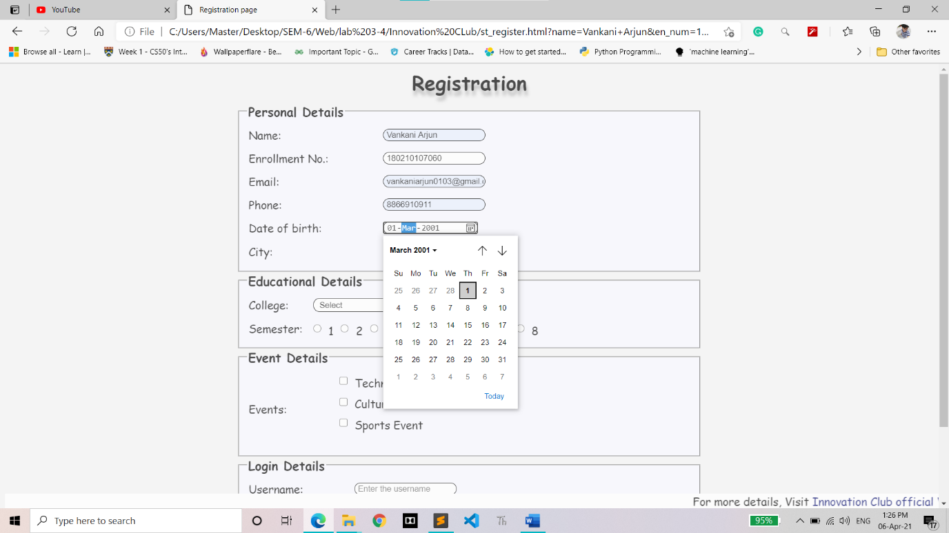

1. **Password entered by user must have minimum 8 characters, must contain at-least one upper case letter and one special character out of ($, %, ^, &, *). If not, alert the user on form submission. User focus () method to focus on the view (input field) that has failed validation so user can directly re-enter the value there.**

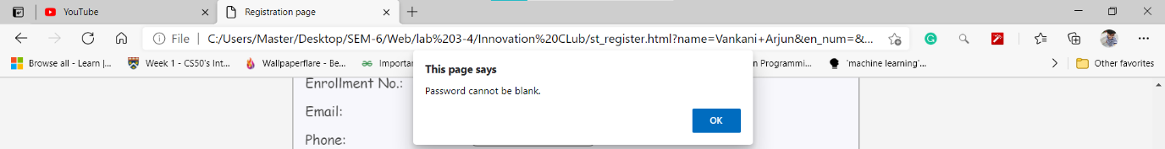

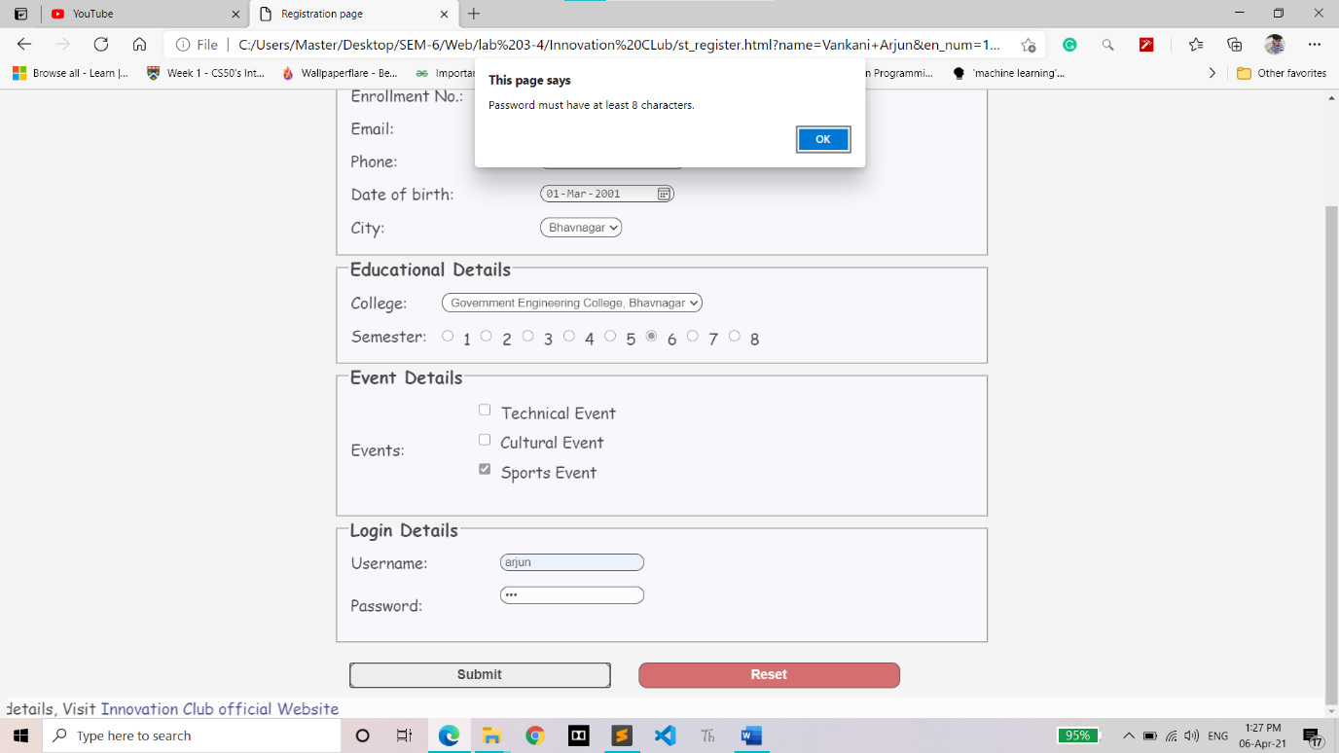

Successfully Register:

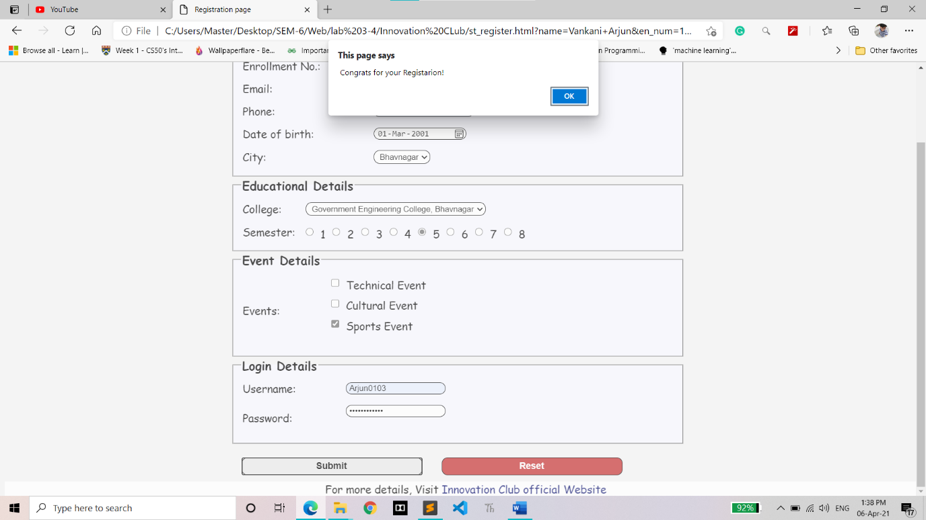

CODE:

function validate() {

const en_num = document.getElementById('en_num');

const email = document.getElementById('email');

const birthdate = document.getElementById('birthday');

const password = document.getElementById('password');

let enNo = 0;

let Email = 0;

let Birthdate = 0;

let Password = 0;

// Enrollment number validation

if (en_num.value == "") {

alert("Enrollment Number cannot be blank.");

en_num.focus();

enNo = 0;

} else if (en_num.value.length != 12) {

alert("Enrollment Number must be length of 12.");

en_num.focus();

enNo = 0;

} else {

enNo = 1;

}

// Email validation

let pattern = /^[a-z0-9._-]+@[a-z0-9.-]+\.[a-z]{2,6}$/;

if (email.value == "") {

alert("Email address cannot be blank.");

email.focus();

Email = 0;

} else if (!(email.value.match(pattern))) {

alert("Please, Enter a valid email address.");

email.focus();

Email = 0;

} else {

Email = 1;

}

// Birthdate validation

var today = new Date();

var year = today.getFullYear();

var date = birthdate.value.split('-');

var age = year - date[0];

if (birthdate.value == "") {

alert("Please enter a valid birth date.");

birthdate.focus();

Birthdate = 0;

} else if (age < 18 || age > 23) {

alert("You are not allowed to register.");

birthdate.focus();

Birthdate = 0;

} else {

Birthdate = 1;

}

// Password validation

var upperCase = /[A-Z]/g;

var specialChar = /[$%^&*!@]/;

if (password.value == "") {

alert("Password cannot be blank.")

password.focus();

Password = 0;

} else if (password.value.length <= 8) {

alert("Password must have at least 8 characters.");

password.focus();

Password = 0;

} else if (!(password.value.match(upperCase))) {

alert("Password must have at least one uppercase.");

password.focus();

Password = 0;

} else if (!(password.value.match(specialChar))) {

alert("Password must have any one of the following characters.");

password.focus();

Password = 0;

} else {

Password = 1;

}

if (enNo == 1 && Email == 1 && Birthdate == 1 && Password == 1) {

alert(" Congrats for your Registarion!")

}

}